From: http://davidstockmanscontracorner.com/the-dead-bull-of-march-2009-and-its-fed-confected-body-double/
Date: October 22, 2018

Shared particularly for: Russell Anthas Sage, who entered the Eighties today.

The Dead Bull Of March 2009 And Its Fed Confected Body Double
It truly does not get more bizarre and despicable than this: It seems that MBS not only sent to Istanbul 15 elite members of the Royal Guard (MBS' body guards which report directly to him) special forces, top intelligence officers and Royal Air Force personal, but among them was Dr. Bonesaw and Mr. Body Double, too.

That's right. Here is the latter garbed in the still warm jacket, shirt, shoes and trousers of the late Mr. Khashoggi---coming out the back door of the consulate just like they said. And compared to his picture going in, Mr. Body Double (aka Mustafa al-Madani) appears to have grown an instant beard, too.


This body double gambit got us to thinking about the apparent bull market which came roaring out of the financial slaughter-house after March 9, 2009. Perhaps the bull is still dead after all, as it should be; and that what we have down in the casino is just a Fed confected simulacrum---the financial equivalent of a body double that has been injected with so many monetary steroids that it kicks, snorts and gallops like the real thing.

One rather powerful suggestion to that end lies in the following 100:1 ratio of Wall Street to main street performance. To wit, the NASDAQ 100 was recently up nearly 220% in inflation-adjusted terms since the pre-crisis peak in 2007 compared to a mere 2.2% gain in industrial production over the same 11 year period.

We are talking apples-to-apples here: Constant dollar stock prices versus real physical output; and also from the prior peak, not the March 2009 stock market bottom.

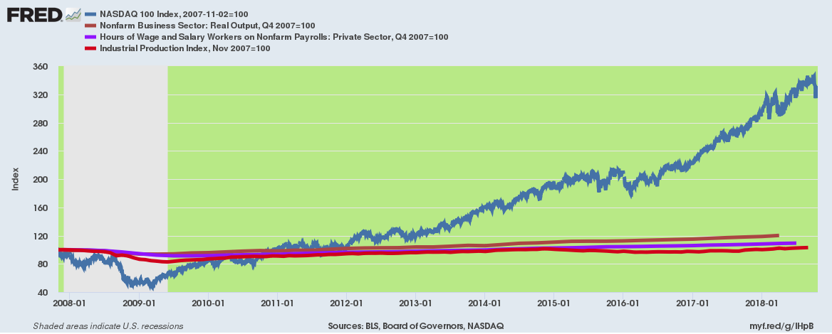
So either the NASDAQ 100 had been savagely repressed at the peak of the housing bubble in November 2007 or the 100:1 ratio of Wall Street versus main street gain in the interim makes no sense whatsoever----in effect, the former [Wall Street] is a bull market body double.

In fact, at the pre-crisis peak in 2007 the stock market was already suspended in the nosebleed section of history. As shown in the chart below, prior to the Greenspan era of money-pumping, the US stock market capitalization amounted to about 40-50% of GDP, but had reached 144% by the dotcom peak in the spring of 2000; and had then regained that aberrational high again by late 2007.

So the question recurs: How has the stock market capitalization continued to soar even higher---to 160% of GDP at the recent high---when the main street economy has literally flat-lined since November 2007?

And we do mean flat line. The core measures of the real economy show that there has been a round trip to essentially nowhere during the past 11 years. At the #112 month mark of this expansion--only seven months from the all-time record of the 1990s---most measures are only slightly above where they started in November 2007.

Thus, as shown in the chart above, total hours worked (purple line) is up only 6.0% during that long span and total nonfarm output less than 20%.

Likewise, real net business investment (not shown) is actually still below its 2000 peak, and real median household income has simply made a 18 year round trip to where it stood in late 1999.

In sum, there was precious little reason for stock market capitalization to be above 140% of GDP in late 2007 at the end of the housing/subprime bubble, and no reason whatsoever for the even further gain to nearly 160% at the recent market highs.

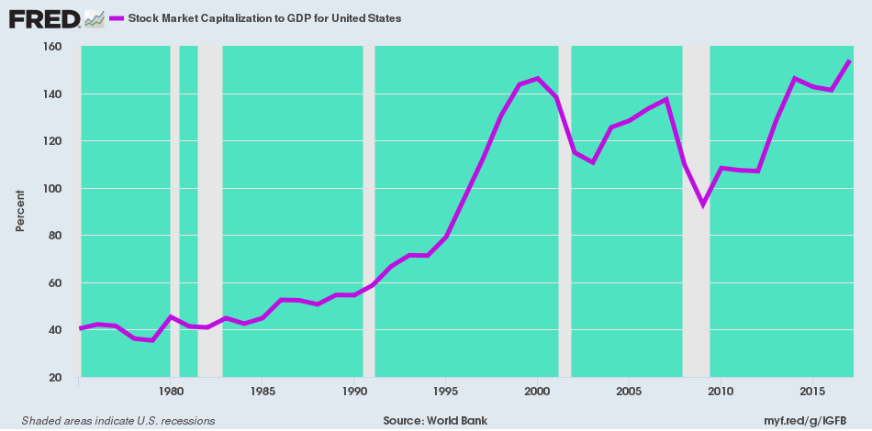
What we are saying is that the effect of Greenspanian central banking has been to financialize the economy and drive a giant, unsustainable wedge between values on Wall Street and economic performance on main street. That has been going on for nearly 30 years now, and with each Fed-driven bubble cycle the de-coupling of Finance and Economy has become ever more tenuous.

In that sense, yes, the real Bull Market was dead long ago. And it is only a matter of time before the Fed-confected and disguised Body Double meet the same fate as Mr. Mustafa al-Madani. [Kashoggi's body double. –FNC] That is to say, it gets exposed for the nasty Fake it actually is.

As shown in the chart below, household assets (purple line) have grown by the staggering sum of $102 trillion since Greenspan discovered the printing press in the basement of the Eccles Building in the fall of 1987 amidst the Black Monday meltdown (6,000 current Dow points in one day). And that is trillions with a "T".

By contrast, nominal GDP is up by only $15.5 trillion during the same 31 year period---meaning that asset values have grown 6.5X faster than economic production.

Do we think that is rational, sustainable or indicative of free market capitalism at work?

Nah!

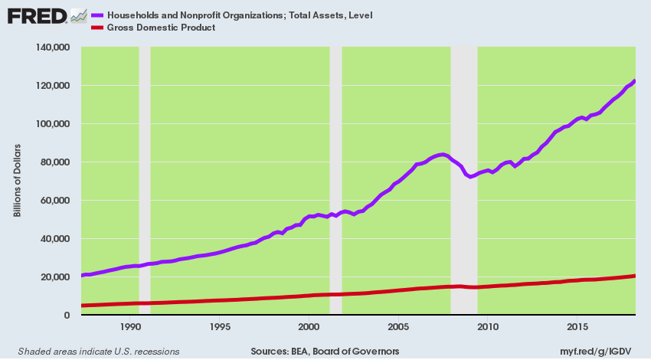
The Wall Street retort, of course, is that regardless of the evident grind on main street, corporate profits are soaring and that explains the sky-high stock averages.

Except, it doesn't.

The key variable in the chart below [I can't find this chart! -FNC] is corporate profits before tax (blue line) because its reflects an apple-to-apples tax rate, and therefore captures organic growth, not the one-time boost from the 21% rate now in effect.

What it shows, of course, is that there has been no growth to speak of since the 2006 peak at $1.9 trillion per year for the entire business sector (i.e. corporate and noncorporate). At $2.2 trillion in the most recent annualized measure, the growth rate over the past 12 years has been a paltry 1.23% per annum.

That is not "booming" in any known universe. In fact, when you squeeze out the inflation there has been hardly any growth at all in real terms.

The profit "growth" boom is really just typical Wall Street snake oil. It counts as "growth" the one-time tax cut, which will anniversary out of the numbers by Q1 2019, and ignores the deep plunge that earnings took after 2014.

To wit, during the LTM period ending in September 2104, S&P 500 reported earnings (the kind CEOs and CFOs certify to the SEC on penalty of jail time) posted at $106 per share. By contrast, based on the trend to date, the LTM earnings will be about $129 per share at best, or $123 on a comparable tax rate basis to the level four years ago.

So the organic growth rate during the last four years----and at the top of the business cycle, which can only go down from here---was just 3.8% per annum!

What the stock peddlers never mention, of course, is the dips in-between when they are happening. Thus, between September 2014 and March 2016, S&P 500 reported LTM earnings plunged by 18.5% t0 just $86 per share----meaning that most of the "gangbusters" earnings gains of recent quarters were just a recovery from the dip--- plus the aforementioned one-time tax reduction.

The litmus test, again, is the growth rate over the cycle. And back in Q2 2007 at the pre-crisis peak, S&P 500 reported earnings posted at $85 per share on an LTM basis. So during the last 11 years, the peak-to-peak growth rate (CAGR) has been just 3.4% per annum; and when you vacate the inflation from the CAGR, it computes to less than2% per year.

Nevertheless, PE multiples now levitate at top-of-the-world highs. This morning, the Russell 2000 was valued at 51X reported earnings, while the NASDAQ 100 and S&P 500 were valued at 25X and 23X reported earnings, respectively.

Let's see. Why would you want to pay 23-50X for earnings growth at a trend rate of3.4% for the past 11 years running, and at the octogenarian phase of the business cycle?

That is to say, all PE multiples are not created equal, notwithstanding the fact that the talking heads of bubblevision never even remotely acknowledge that crucial point. But obviously, a high PE multiple appropriate to an environment with tailwinds and which is posted during the second year of a business recovery is not relevant at all to year #11 of an aging expansion when gale force headwinds are everywhere evident.

In this regard, we are absolutely confident that recessions have not been outlawed and that one is due in the next year or two. Accordingly, GAAP earnings are likely to hit $70 per share at the next recession bottom long before they hit $170 per share per the current two-year out Wall Street hockey sticks.

During our apparently semi-regulator Fox Business appearance earlier today, we got braced with the same old question by our host, perma-bull cheerleader, Stuart Varney.

He wanted to know when the next crash is coming, and we said asked the Fed!

https://www.youtube.com/watch?v=Qw69tvbLf68&feature=youtu.be [Stockman from 53 sec to the end. THIS does not seem to be "the chart below" -FNC]

The monetary politburo, in fact, has ordered up a doozy because it is now plowing full speed ahead with QT (quantitative tightening) at a $600 billion annual rate. And it is effectively dumping these massive quantities of existing government paper at the same time that the US Treasury will be borrowing $1.2 trillion this year to fund the official deficit plus all of the off-budget loopholes.

Our Keynesian monetary central planners have plunged ahead into this bubble-killing pivot to QT, of course, as kind of a victory lap.

They mistakenly think they have brought the Nirvana of Full Employment to the USA, and are hell bent on reloading their dry powder to be in position to bailout the next economic downturn; and to thereby retain their mandate to peg, manipulate and falsify virtually every price in the financial markets-----the very signaling system that is the very lifeblood of free market capitalism.

As it happened, even Stuart Varney calmed down sufficiently to utter a "you don't say" about the unassailable fact that there is $1.8 trillion of homeless debt hitting the bond pits, and that the market clearing yield therefore has nowhere to go except up to 4.00% and well beyond.

In fact, it is becoming more evident by the day that the ECB will shutdown is [it's] QE printing press in December; that the People's Bank of China will have no choice except to dump dollar reserves and buy yuan to stem capital flight and parry the Donald's insane no holds barred Trade War; and that even Japan is being forced to taper its massive QE policy owing to the crushing effect on banks and savers of its ultra-QE policy.

As the Donald tweeted over the weekend, China needs to be punished with 25% tariffs on $517 billion of imports if needs be in order to make the concessions his motely band of protectionist advisors have concocted. And as we have observed, those Chinese imports are the price-setting marginal supply and account for less than 30% of the goods in their respective categories.

So what is coming down the pick [pike] is a large pick-up in inflation on $1.7 trillion of Chinese-import driven goods, or 40% of all goods consumed annually by the US economy.

In short, the Fed painted itself in a corner with
- eight straight years of negative real interest rates and
- massive monetization of the debt.
Now
- the Donald's Trade War and
- the GOPs descent into abject Fiscal Profligacy
leaves the Fed with no choice except to keep on normalizing rates and shrinking it [its] balance sheet until the greatest Everything Bubble of all time finally splatters.

Like its Saudi namesake, we thing [think] the Bull's body double is about to get exposed and when it takes the fall it will be a doozy!.

The Day Stocks (the DOW) bottomed out.
Last twelve months (LTM), also commonly designated as trailing twelve months (TTM), indicates the timeframe of the immediately preceding 12 months.

